**SWEDEN ORTHOPEDIC DEVICES MARKET**

According to Intelli, the Sweden orthopedic devices market was valued at USD 271.8 million in 2024 and is projected to reach USD 330.62 million by 2032, growing at a CAGR of 3.38% from 2024 to 2032.

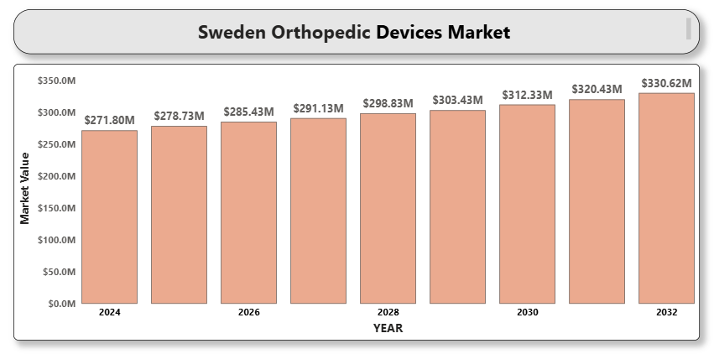

The Sweden orthopedic devices market is experiencing steady growth driven by an aging population, increasing sports-related injuries, and a growing number of orthopedic surgeries, particularly for joint reconstruction and spine-related disorders. The country has a well-established healthcare infrastructure, strong reimbursement policies, and a high level of awareness regarding advanced orthopedic treatments, all of which contribute to market expansion. In addition, rising demand for minimally invasive surgeries and technological innovations such as 3D printing, robotics-assisted surgeries, and smart implants are further shaping the competitive landscape.

**Sweden Orthopedic Devices Market Definition**

Orthopedic devices refer to medical tools and implants used for correcting bone and joint disorders or injuries. These devices support bone healing, replace damaged joints, correct deformities, or aid in physical movement and rehabilitation. The primary product categories include joint reconstruction implants, spinal devices, trauma fixation systems, arthroscopy equipment, and orthobiologics. These devices are employed in various settings such as hospitals, orthopedic clinics, ambulatory surgical centers, and research institutions.

Technological advances like robotic-assisted surgical systems and bioresorbable materials are gaining prominence, improving clinical outcomes and patient satisfaction.

**Sweden Orthopedic Devices Market Overview**

The orthopedic devices market in Sweden is marked by high procedural volumes, well-developed surgical infrastructure, and a strong emphasis on early mobility and recovery. The prevalence of osteoarthritis, osteoporosis, and traumatic injuries among Sweden’s aging population is a key driver for joint replacements and trauma fixation solutions.

The country's public healthcare system provides nearly universal access to orthopedic care, and regional health authorities continuously invest in upgrading surgical facilities and expanding outpatient orthopedic services. However, challenges such as surgical backlog, limited orthopedic specialists in rural areas, and the cost burden of advanced implants could hamper market efficiency.

Nevertheless, strategic partnerships, local manufacturing support, and government initiatives promoting early rehabilitation and home-based orthopedic recovery offer substantial opportunities.

**Sweden Orthopedic Devices Market Segmentation Analysis**

**Market Segmentation by Product Type:**

• Joint Reconstruction Devices

• Spinal Devices

• Trauma Fixation Devices

• Orthobiologics

• Arthroscopy Devices

Joint reconstruction devices, particularly hip and knee implants, dominate the Swedish orthopedic devices market. Spinal implants and trauma fixation systems are also widely adopted in hospital and outpatient settings. The demand for orthobiologics is growing due to their ability to accelerate bone healing and improve surgical outcomes.

**Market Segmentation by Application:**

• Hip Replacement

• Knee Replacement

• Spine Disorders

• Sports Injuries

• Other Applications

Hip and knee replacements remain the most common procedures in Sweden due to the high prevalence of degenerative joint diseases among the elderly. The sports injury segment is growing rapidly, driven by increased participation in recreational and competitive athletics.

**Market Segmentation by End User:**

• Hospitals

• Orthopedic Clinics

• Ambulatory Surgical Centers

• Research and Academic Institutes

Hospitals continue to be the leading end users, benefitting from strong government funding and comprehensive orthopedic departments. Ambulatory surgical centers are expanding with a focus on same-day joint and spine surgeries.

**Market Segmentation by Region:**

• Northern Sweden

• Central Sweden

Southern Sweden, including urban areas like Stockholm and Malmö, leads in orthopedic procedures due to higher healthcare spending and availability of specialized care. However, efforts are underway to improve access in remote areas of Northern Sweden.

**Key Players**

The Sweden orthopedic devices market is served by a mix of global and regional manufacturers. Key players include Zimmer Biomet Holdings Inc., Stryker Corporation, Johnson & Johnson (DePuy Synthes), Smith & Nephew plc, Medtronic plc, B. Braun Melsungen AG, Globus Medical Inc., and Össur hf. These companies are recognized for innovation, broad product portfolios, and strong distribution networks. Competitive advantages are built on advanced technologies like navigation-assisted systems, robotics, and biocompatible implants.

**Key Developments**

• November 2024: Auxein, the world leader in orthopedic products, introduced innovative orthopedic and arthroscopy products like the AV-Wiselock Plates, Osteochondral Transfer System, and the Reusable Suture Passer

• In 2024, Össur acquired FIOR & GENTZ, specializing in upper-limb prosthetics, strengthening its position in the global prosthetics market.

**Market Attractiveness**

Sweden’s orthopedic devices market is considered highly attractive due to its aging population, strong public healthcare infrastructure, and high per capita healthcare spending. Widespread adoption of digital technologies, robust reimbursement models, and early implementation of innovations such as 3D-printed implants contribute to market appeal. The demand for personalized implants and rapid recovery solutions continues to drive investment and R&D.

**Porter’s Five Forces**

• Threat of New Entrants: Moderate.barriers, but niche startups entering with innovative technologies can still gain a foothold.

• Bargaining Power of Suppliers: Low to Moderate. With many component and raw material providers, supplier power is restrained, although dependency on biocompatible material suppliers is increasing.

• Bargaining Power of Buyers: High. Centralized public procurement through Sweden's healthcare system gives institutions strong negotiating leverage.

• Threat of Substitutes: Low. Physiotherapy and non-surgical alternatives may delay interventions but are not viable substitutes for orthopedic implants in severe cases.

• Industry Rivalry: High. Global giants compete intensely on pricing, innovation, and service quality. Continuous technological upgrades and surgeon preferences intensify market competition.

**TABLE OF CONTENTS**

1. **INTRODUCTION OF SWEDEN ORTHOPEDIC DEVICES MARKET**1.1 Overview of the Market   
   1.2 Scope of Report A close-up of hands holding a tablet and a pen

   Description automatically generated  
   1.3 Assumptions
2. **EXECUTIVE SUMMARY**
3. **RESEARCH METHODOLOGY**3.1 Data Mining   
   3.2 Validation   
   3.3 Primary Interviews   
   3.4 List of Data Sources
4. **SWEDEN ORTHOPEDIC DEVICES MARKET OUTLOOK**4.1 Overview   
   4.2 Market Dynamics   
   4.2.1 Drivers    
   4.2.2 Restraints    
   4.2.3 Opportunities    
   4.2.4 Trends    
   4.3 Porters Five Force Model   
   4.4 Value Chain Analysis
5. **SWEDEN ORTHOPEDIC DEVICES MARKET, BY PRODUCT TYPE**5.1 Joint Reconstruction Devices   
   5.2 Spinal Devices   
   5.3 Trauma Fixation Devices   
   5.4 Orthobiologics   
   5.5 Arthroscopy Devices   
   5.6 Others
6. **SWEDEN ORTHOPEDIC DEVICES MARKET, BY APPLICATION**6.1 Hip Replacement   
   6.2 Knee Replacement   
   6.3 Spine Disorders   
   6.4 Sports Injuries   
   6.5 Other Applications
7. **A close-up of hands holding a tablet and a pen

   Description automatically generatedSWEDEN ORTHOPEDIC DEVICES MARKET, BY END USER**7.1 Hospitals   
   7.2 Orthopedic Clinics   
   7.3 Ambulatory Surgical Centers   
   7.4 Research and Academic Institutes
8. **SWEDEN ORTHOPEDIC DEVICES MARKET, BY REGION**8.1 Northern Sweden   
   8.2 Central Sweden   
   8.3 Southern Sweden
9. **SWEDEN ORTHOPEDIC DEVICES MARKET COMPETITIVE LANDSCAPE**9.1 Overview   
   9.2 Company Market Ranking   
   9.3 Key Development Strategies
10. **COMPANY PROFILES  
    10.1 Zimmer Biomet Holdings Inc.**10.1.1 Overview    
    10.1.2 Financial Performance    
    10.1.3 Product Outlook    
    10.1.4 Key Developments    
    **10.2 Stryker Corporation**10.2.1 Overview    
    10.2.2 Financial Performance    
    10.2.3 Product Outlook    
    10.2.4 Key Developments    
    **10.3 Johnson  & Johnson (DePuy Synthes)**10.3.1 Overview    
    10.3.2 Financial Performance    
    10.3.3 Product Outlook    
    10.3.4 Key Developments    
    **10.4 Smith  & Nephew plc**10.4.1 Overview    
    10.4.2 Financial Performance    
    10.4.3 Product Outlook    
    10.4.4 Key Developments    
    **10.5 Medtronic plc**10.5.1 Overview    
    10.5.2 Financial Performance    
    10.5.3 Product Outlook    
    10.5.4 Key Developments    
    **10.6 B. Braun Melsungen AG**10.6.1 Overview    
    10.6.2 Financial Performance    
    10.6.3 Product Outlook    
    10.6.4 Key Developments    
    **10.7 Globus Medical Inc.**10.7.1 Overview    
    10.7.2 Financial Performance    
    10.7.3 Product Outlook    
    10.7.4 Key Developments    
    **10.8 Össur hf.**10.8.1 Overview    
    10.8.2 Financial Performance    
    10.8.3 Product Outlook    
    10.8.4 Key Developments
11. **A close-up of hands holding a tablet and a pen

    Description automatically generatedKEY DEVELOPMENTS**11.1 Product Launches/Developments   
    11.2 Mergers and Acquisitions   
    11.3 Business Expansions   
    11.4 Partnerships and Collaborations
12. **A close-up of hands holding a tablet and a pen

    Description automatically generatedAPPENDIX**12.1 Related Research